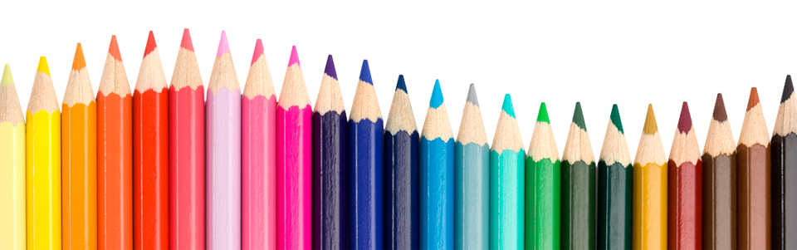

PreK-K Back to School Supply List
● 1 Pack of Crayola Jumbo Crayons (8 Count)
● 1 Pack of My First Pencils (4 Count)
● 1 Pack of Colored Markers (Washable/Non-Skinny Preferred) (10 Count)
● 1 Package of Watercolor Paints (8 Colors Minimum)
● 1 Package of Thick Dry Erase Markers (4 Count; Assorted Colors Preferred)
● 3 Jumbo Glue Sticks
● 1 Pair of Spring-Loaded Scissors (Available at Dollar tree or on Amazon)
● 1 ½” Binder (Solid Colors)
● 1” Binder (Solid Colors; Preferably White)
● 2-Pocket Folder (Solid Colors)
● 4 Cans of Play-Doh
● 3 Boxes of Tissues
● 3 Rolls of Paper Towels
● 2 Containers of Disinfectant Wipes
● 1 Box of Gallon Ziploc Bags
*Please label all bags/outer packaging before bringing items in!

